Blockchain Lab2 report
Part A – Curve arithmetic
Question1:
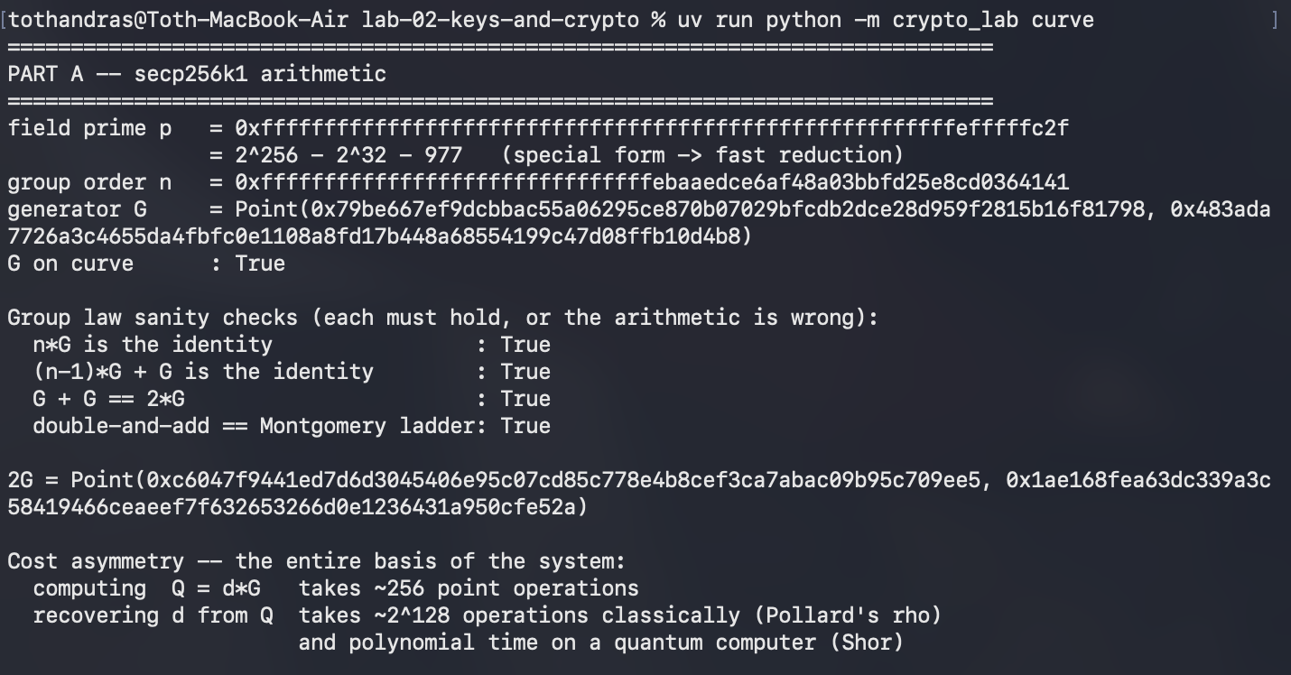
All four sanity checks returned true.
Question2: Why n*G = $O$ must hold?
$O$ is the starting point of the curve. Adding G steps means moving forward on the curve. Since the curve contains exactly n points, taking n steps should bring us back to the start $O.$
Question3: What would be broken if the implemented order were wrong by one?
Cryptography relies on numbers wrapping back to zero at n. If the code wraps at n+1, math says n+1 = 0. Scalar math and geometry stop agreeing. ECDSA signature divides verification divides numbers modulo n. Using n+1‬‬ produces the wrong scalar value, so every legitimate transaction signature is rejected as invalid. The valid n is a hige prime number, meaning n+1 is an even number, resulting in easier recovery of the private key.

Part B – ECDSA, and the nonce
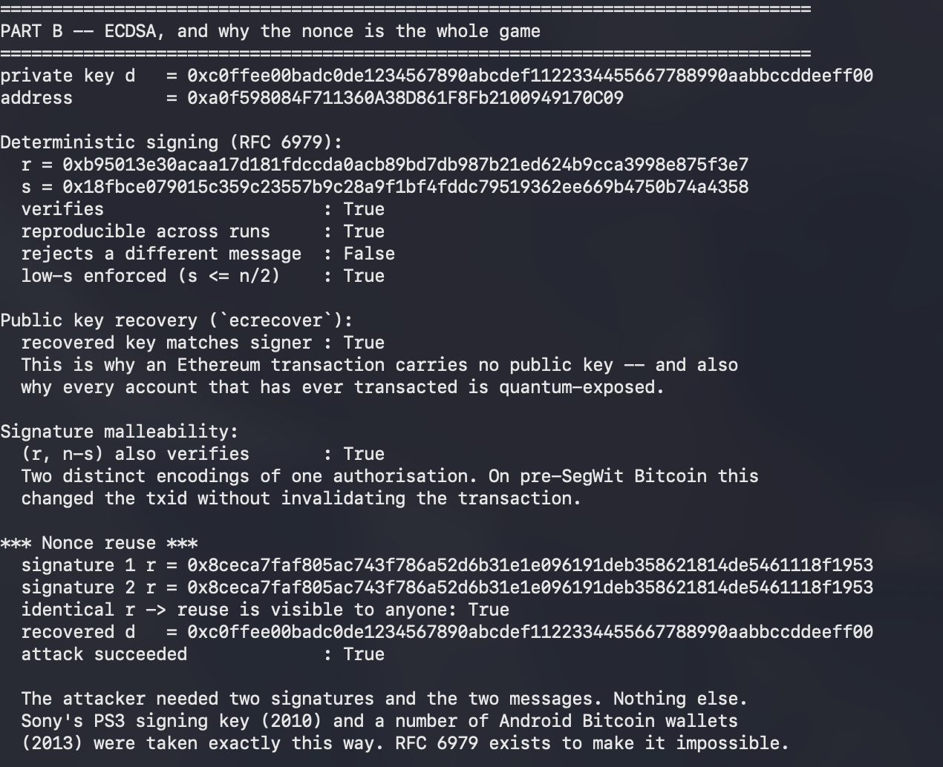
private key d = 0xc0ffee00badc0de1234567890abcdef1122334455667788990aabbccddeeff00
recovered d = 0xc0ffee00badc0de1234567890abcdef1122334455667788990aabbccddeeff00
Question1: Why RFC 6979 removes the vulnerability without making k predictable to an attacker?
It replaces RNG with a deterministic derivation. The value of k depends on both the private key d and message hash z.
k = HMAC-SHA256 (key = d, data = z)‬‬‬‬‬‬ ‬‬‬
For any private key to produce the exact same k twice is to sign the exact same massage hash twice. If you sign the same message twice, the entire signature (r, s) is identical, so it leaks nothing. Evaluatin requires the secret key, which is the signers private key d. For the signer it is fully deterministic, but for the attacker without d, It seems random. The nonce seems random to any observer without the private key.

Part C – HD wallets
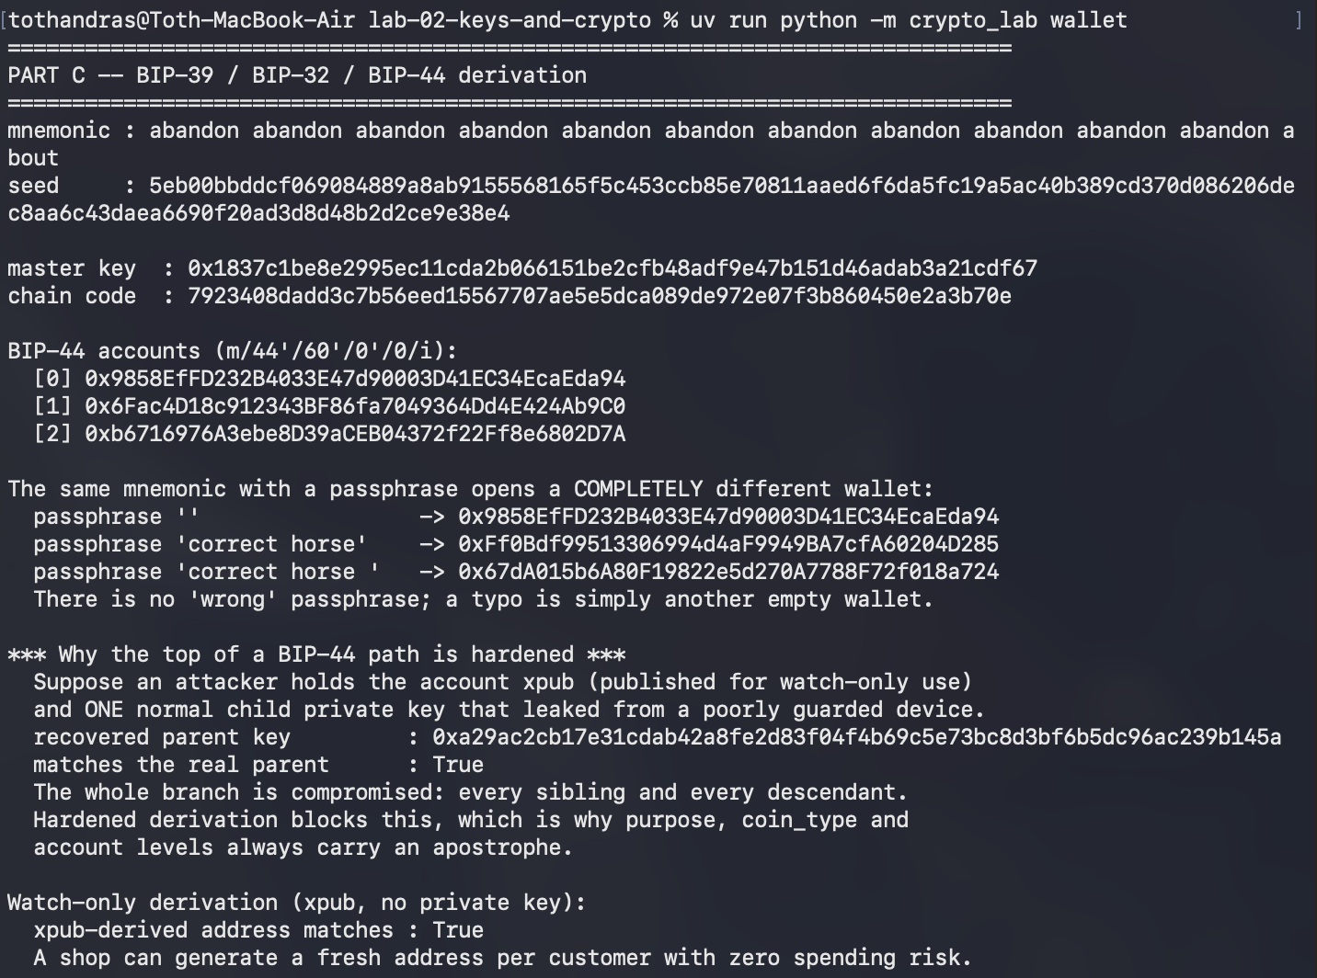
Question1: Why the same attack fails against a hardened child?
In non-hardened child derivation, the offset scalar is calculated using public key and chain code. In this case, anyone holding yhe xpub can eveluate the offset scalar. Once the attacker obtains the child private key, they can recover the parent private key. In hardened derivation function, we use the parent private key instead of oublic key. The attacker need k parent to calculate the offset, but it cannot be recovered without k parent. One equation with 2 unknown variables
Question2: Real deployment scenario
An online store often puts its public key (xpub) on a web server to safely create new deposit addresses for customers without storing master passwords there. However, if the store gives a single child private key to a small side service (automated refund bot) and a hacker breaches that bot, the attacker can combine that one leaked child key with the store's public xpub to do simple math, instantly calculate the master private key, and steal all the funds from every address on the entire account.

Part D – Post-quantum cost
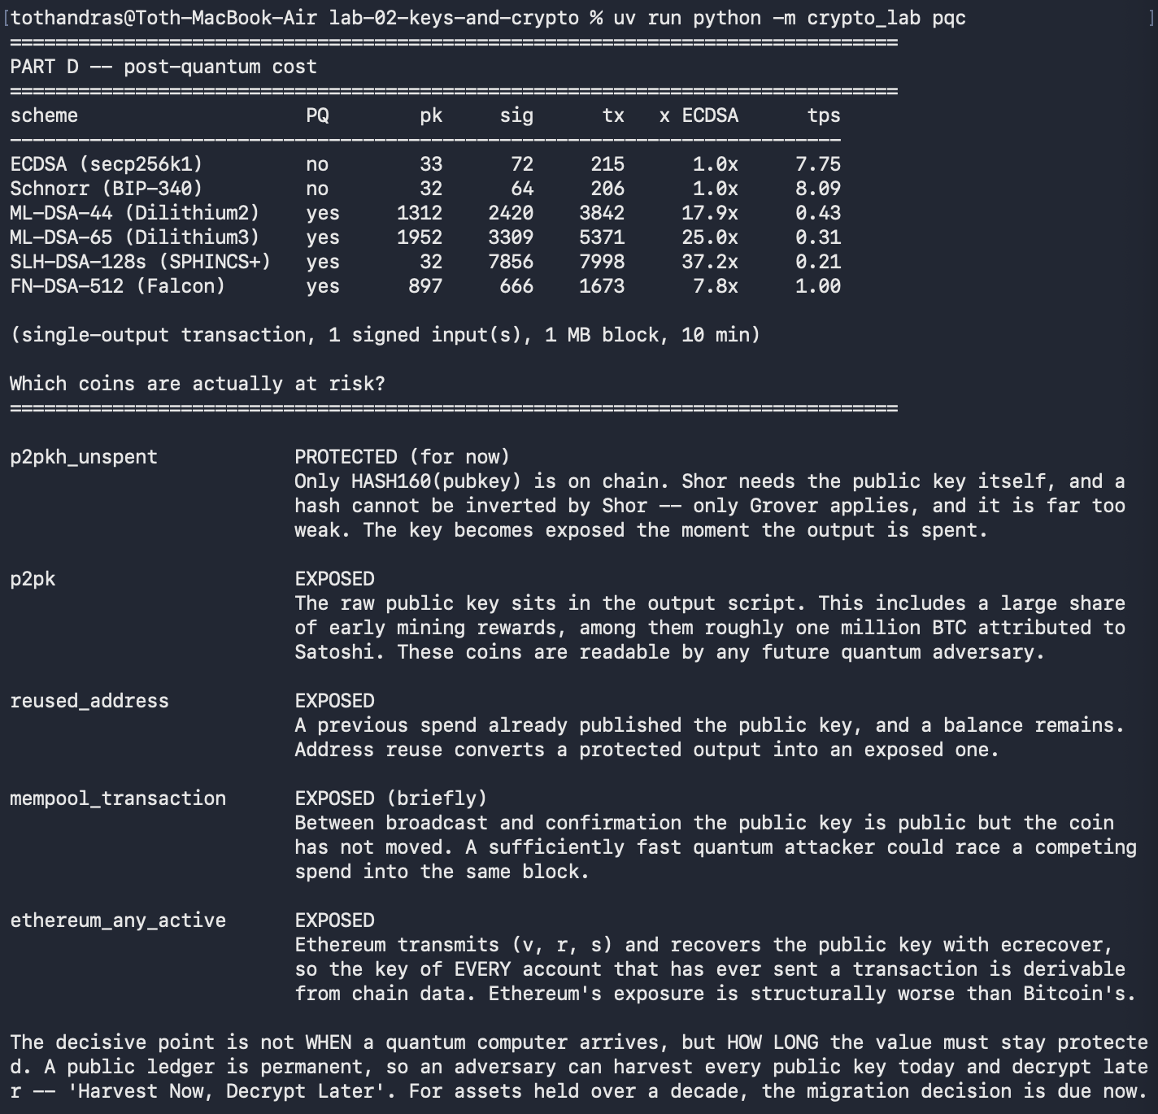

Question1: For an asset that must remain secure for fifteen years, is the migration decision due now or later?
For an asset that must remain secure for 15 years, the migration decision is due now. Under the Harvest-Now-Decrypt-Later threat model, an attacker does not need a quantum computer today, they can simply save permanently visible public keys from the blockchain right now and wait. If the asset must stay safe for fifteen years, any quantum machine built at any point during that time will instantly break the saved key and steal the funds, and because redesigning the entire blockchain with massive post-quantum signatures will take many years of hard work.

Implementation risk:

